**ASSIGNMENT : LAB 01**

**SUBJECT : Object Oriented Programming**

**ROLL NO : 24BSAI29**

**SUBMITTED BY : SYED MUHAMMAD QASIM**

**SUBMITTED TO : Ms. Mehwish shaikh**

Mehran University of Engineering and Technology Jamshoro

Name: Syed Muhammad Qasim Roll No: 24BSAI29

Score: Signature of the Lab Tutor: Date: 15 JAN 2024



**To Set up Java Programming Environment**

|  |  |  |  |  |  |  |  |
| --- | --- | --- | --- | --- | --- | --- | --- |
| **LAB PERFORMANCE INDICATOR** | **SUBJECT KNOWLEDGE** | **DATA ANALYSIS AND INTERPRETATION** | **ABILITY TO CONDUCT EXPERIMENT** | **PRESENTATION** | **CALCULATION AND CODING** | **OBSERVATION/ RESULTS** | **SCORE** |
| **OBJECTIVE NO:** |  |  |  |  |  |  |  |

**Objectives**

* To setup Java programming environment

**Tools**

* Notepad++/Eclipse/IntelliJ Idea

|  |  |
| --- | --- |
| **Keywords:** Java, Platform Independent ,JDK,JRE,JVM | **Duration:** 03 hours |

# Overview of lab

* 1. **Introduction to Java**:

Java is a programming language created by James Gosling at Sun Microsystems, Inc. in 1991. The target of Java was to write a program once and then run programs on multiple operating systems. The first publicly available version of Java (Java 1.0) was released in 1995. Sun Microsystems was acquired by the Oracle Corporation in 2010. In 2006 Sun started to make Java available under the General Public License (GPL). Oracle continues this project called Open JDK.

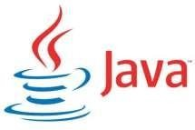

# Features of Java:

1. Java is object oriented programming language, which supports:
   * [Abstraction](https://beginnersbook.com/2013/03/oops-in-java-encapsulation-inheritance-polymorphism-abstraction/)
   * [Encapsulation](https://beginnersbook.com/2013/05/encapsulation-in-java/)
   * [Inheritance](https://beginnersbook.com/2013/05/java-inheritance-types/)
   * [Polymorphism](https://beginnersbook.com/2013/03/polymorphism-in-java/)
2. Java is platform independent. Because the Java compiler converts the source code to bytecode, which is Intermediate Language. Bytecode can be executed on any platform (Operating system) using JVM (Java Virtual Machine).
3. It is easy to learn.
4. It is open-source and free.
5. High performance.
6. Platform Independent

# Principle of java:

Write once, Run Anywhere.

# Why Java is platform Independent?

You can write a java program (on any platform) and use the JVM compiler (called javac) to generate a byte code file (byte code files use the extension .class). This byte code file can be used on any platform (that has installed Java) that’s why Java is called a platform (OS) Independent.

# Introduction to the Java Development Kit:

Java Development Kit (in short JDK) is Kit which provides the environment to develop and execute(run) the Java program. JDK is a kit (or package) which includes two things. Development Tools (to provide an environment to develop your java programs). JRE (to execute java program).

# Introduction to the Java Runtime Environment:

Java Runtime Environment (to say JRE) is an installation package which provides environment to only run (not develop) the java program (or application) onto your machine. JRE is only used by them who only want to run the Java Programs.

# Introduction to the Java Virtual machine:

Java Virtual machine (JVM) is a very important part of both JDK and JRE because it is contained or inbuilt in both. Whatever Java program you run using JRE or JDK goes into JVM and JVM is responsible for executing the java program line by line hence it is also known as interpreter.

# JDK= JRE + Development Tools JRE= JVM + Library classes

* 1. **Three platforms of the Java programming language:**
     1. **J2SE (Java Platform, Standard Edition):**
        + It stands for standard edition.
        + Also well-known as Core Java, this is the most basic and standard version of Java. It’s

the purest appearance of Java, a basic establishment for all other editions.

* + - * J2SE is used to create applications for Desktop.

# J2ME (Java Platform, Micro Edition):

* + - * Java ME stands for Java micro edition.
      * This used for the applications running on small devices, mobiles, and embedded system.

# J2EE (Java Platform, Enterprise Edition):

* + - * Stands for Java enterprise edition for applications which run on servers, for example web sites.
      * The Enterprise edition of Java has a superior usage of Java, like a growth ofweb services, networking, server-side scripting and further a variety of web-based applications.

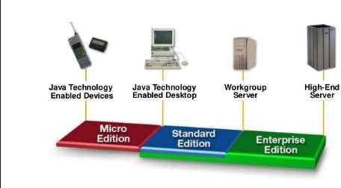

* 1. **How to Download & Install JDK 20 in Windows**:

**Step 1:** Go to <https://www.oracle.com/pk/java/technologies/downloads/> Click on Download JDK, for java latest version.

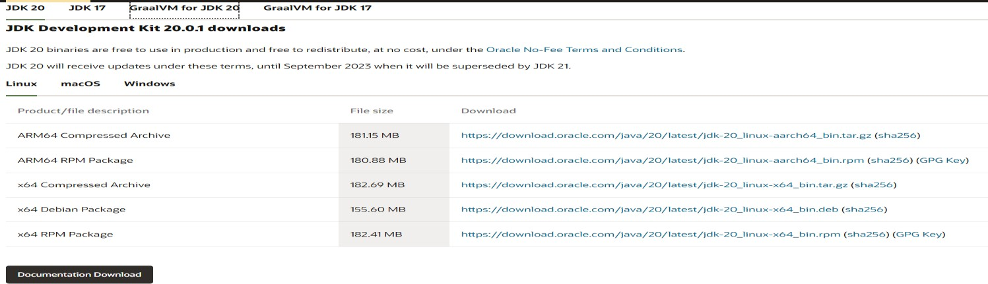

**Step 2)** Next,

1. Accept License Agreement
2. Download latest Java JDK for your version (32 or 64 bit) of java for Windows.

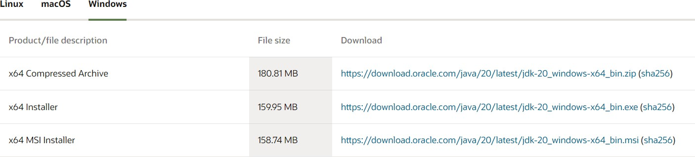

**Step 3)** once the download is complete, run the exe for install JDK. Click Next

**Step 4)** Select the PATH for Java installation and click **next**. **Step 5)** Once installation is complete click **Close**.

**Note:** If you don’t understand that how to install JDK then watch this video

https://[www.youtube.com/watch?v=IJ-PJbvJBGs](http://www.youtube.com/watch?v=IJ-PJbvJBGs)

* 1. **How to set Environment Variable in Java**

The PATH variable gives the location of executables like javac, java etc. It is possible to run a program without specifying the PATH but you will need to give full path of executable like C:\Program Files\Java\jdk-20.0.1\bin\javac A.java instead of simple javac A.java. The CLASSPATH variable gives location of the Library Files.

**Step 01**: Right-click the Computer icon and choose Properties, or in Windows Control Panel, choose System.

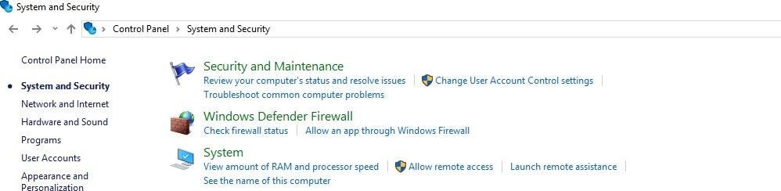

**Step 02:** Click on System and then click on advanced system settings.

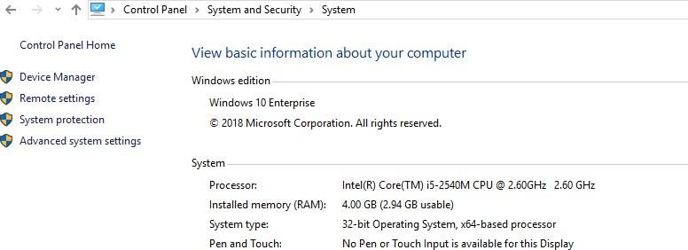

**Step 03:** After clicking on advanced setting, click on Environment variable

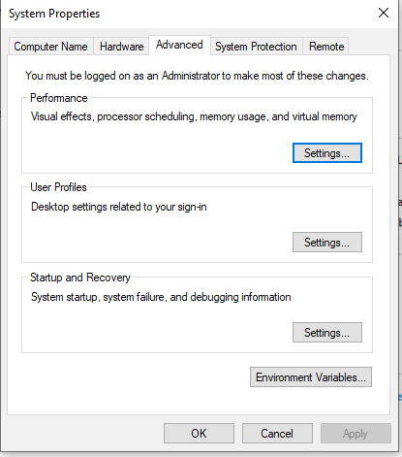

**Step 04**: Click on New:

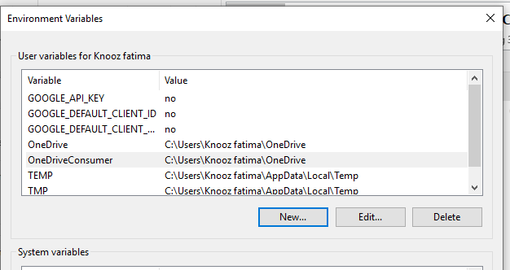

**Step 05**: Type variable name Path:

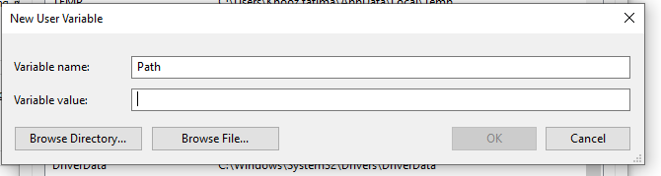

**Step 06**: Copy the location of bin folder

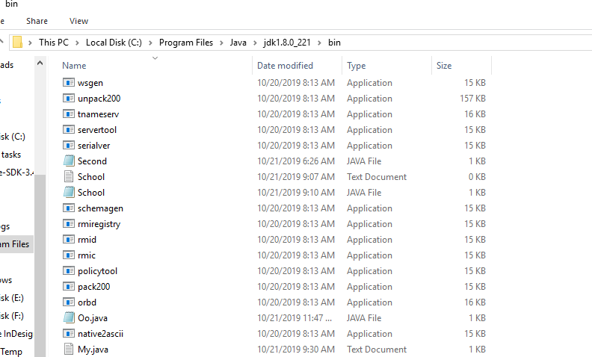

**Step 07**: Paste the location and then click on OK:

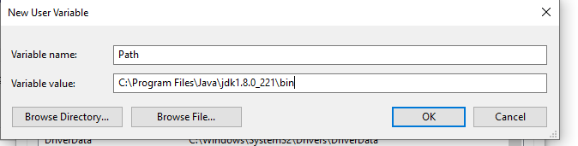

# Using Intelli J:

**Step 1**: Open Intelli J then click on file then click on **Next**

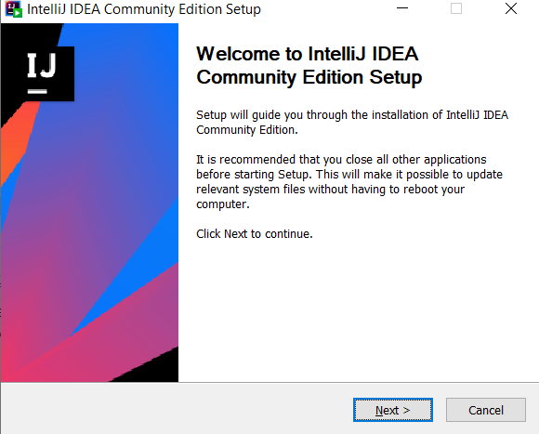

**Step 2**: Check all the options as shown in the figure below. Click Next and wait till the installation.

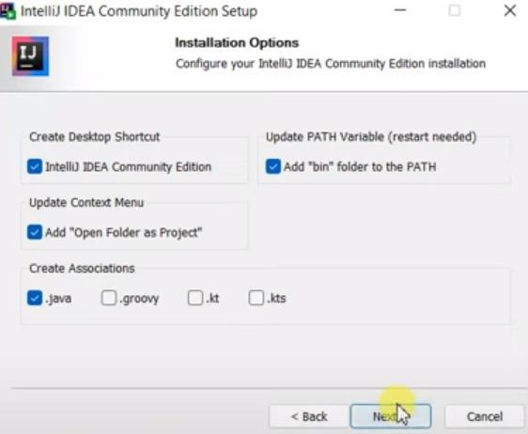`

**Step 3:** After installation, Click on **Reboot Now** and click on finish.

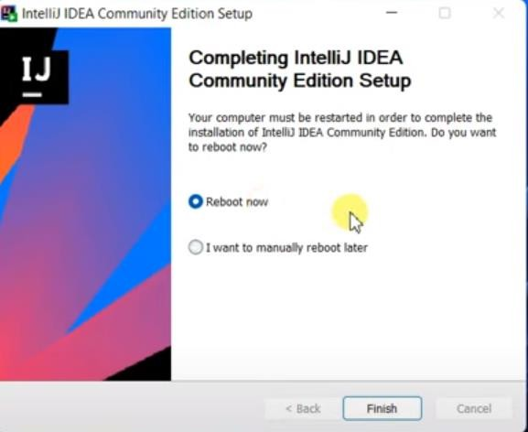

**Note:** If you don’t understand then watch this video to install Intelli J. <https://www.youtube.com/watch?v=viNG3VVnzFE&ab_channel=GeekyScript>

**Step 4**: Write the code then compile and run.

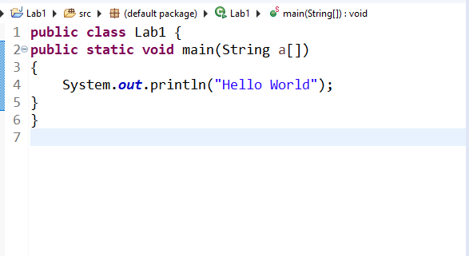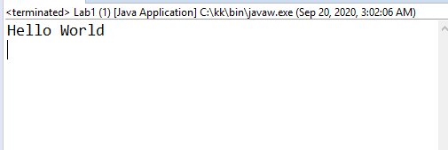

# Demonstration of practice examples.

* 1. **Example 1**:

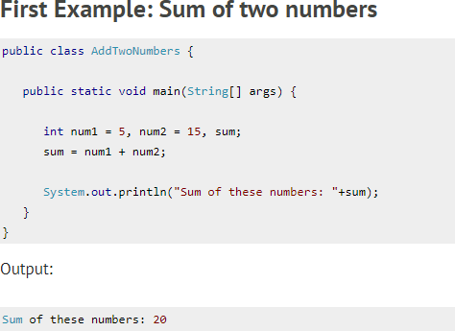

**Lab Exercise:**

1. Write a program to print your name, batch and department name on different lines.

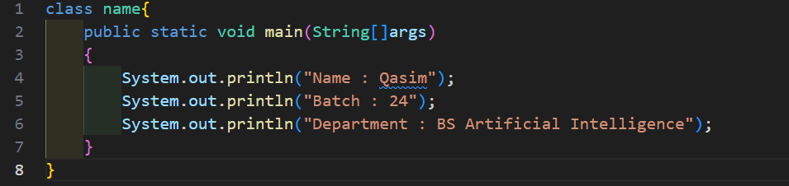

**Result:**

1. Write a program to print your favorite quote.

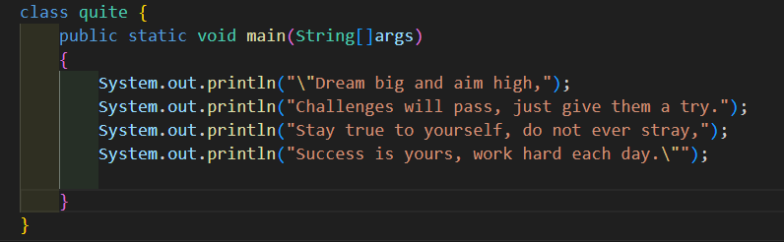

**Result:**

1. Write a program to print the multiplication table of 5 up to 10.

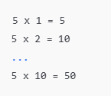

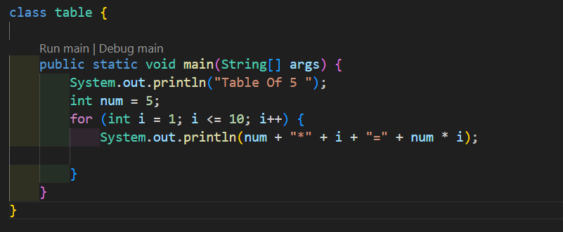

**Result:**

1. Write a program to display a simple pattern using asterisks.



**Result:**

